

Moamalat — Correspondence System
Workflow & Notification POC
UML Activity Diagrams — IBM Proof of Concept

Complete Workflow Overview
All five flows shown together with their connections. Dashed arrows indicate links between flows.
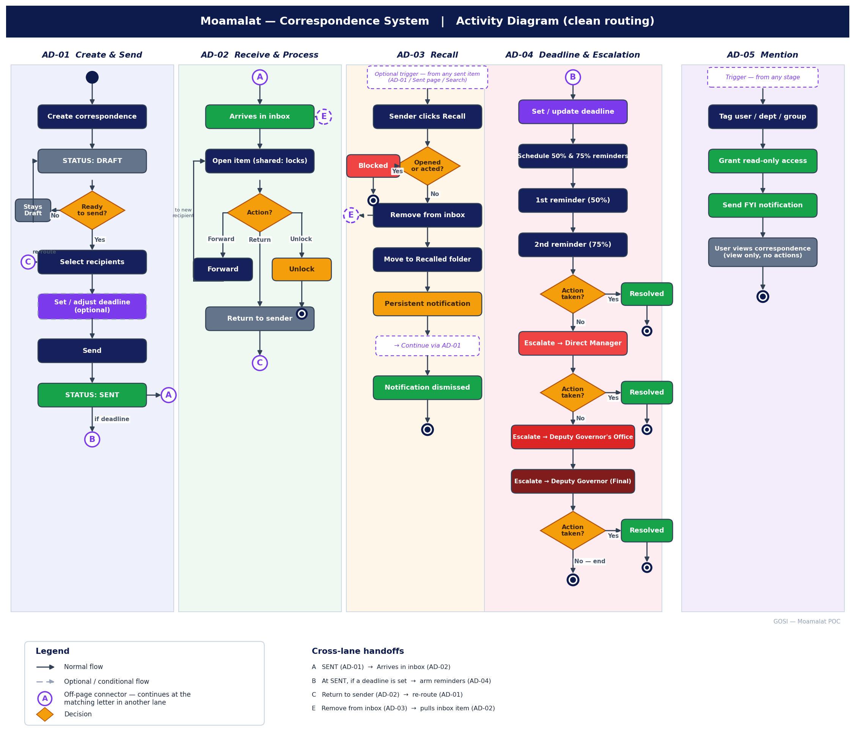

AD-01 — Create & Send
Correspondence is created as Draft. If not sent, it stays Draft. Once sent it leaves Draft permanently. Deadline can optionally be set before or after sending.
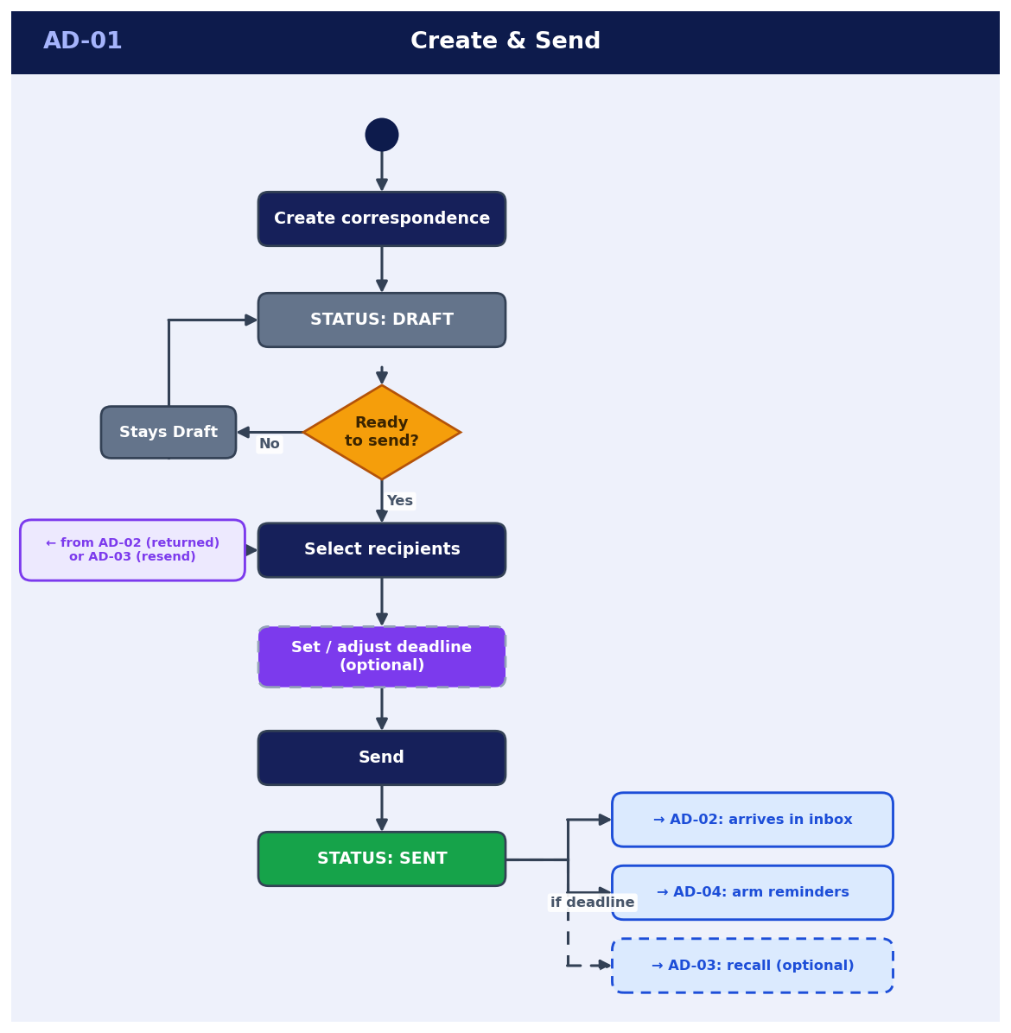

AD-02 — Receive & Process
Item arrives in a shared inbox and locks on open. Member can forward (re-routes via AD-01), return, or unlock.
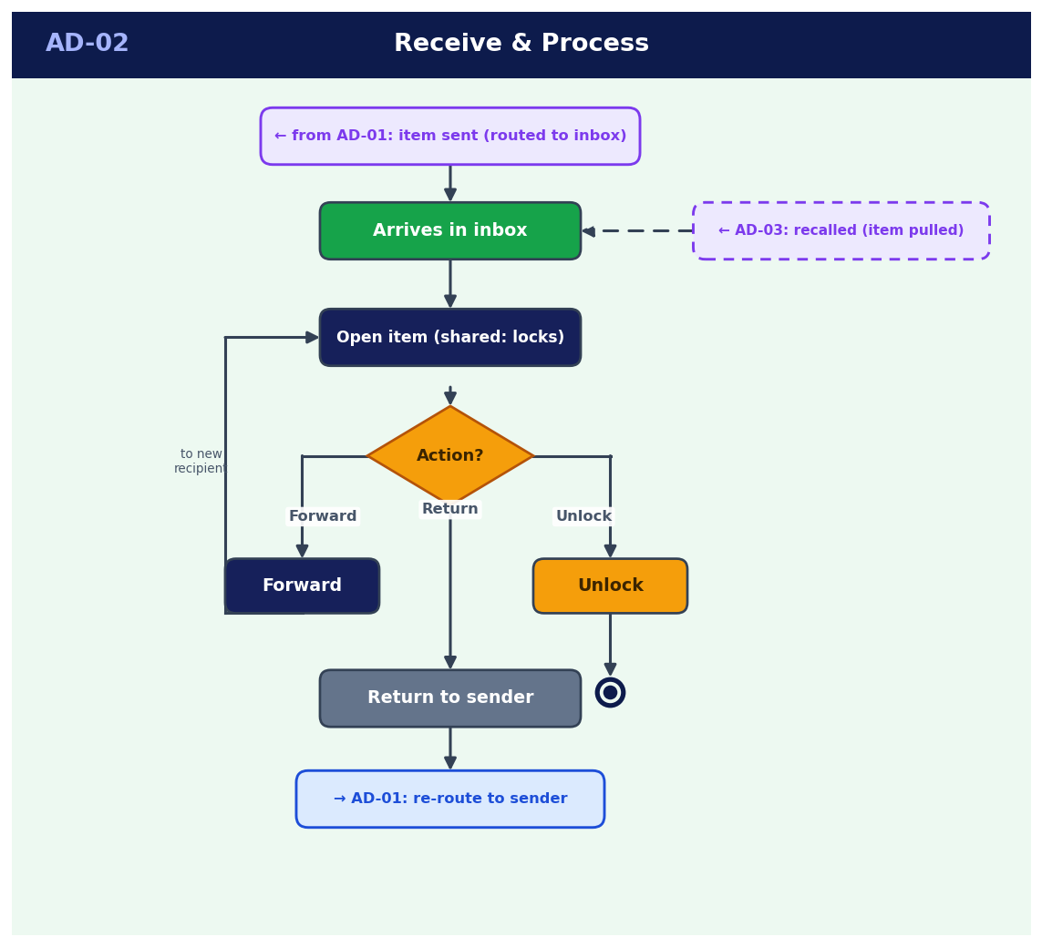

AD-03 — Recall
Recall blocked if recipient opened or acted. On success, item moves to Recalled folder with a persistent notification, then continues via AD-01 to resend. Delete is not permitted.
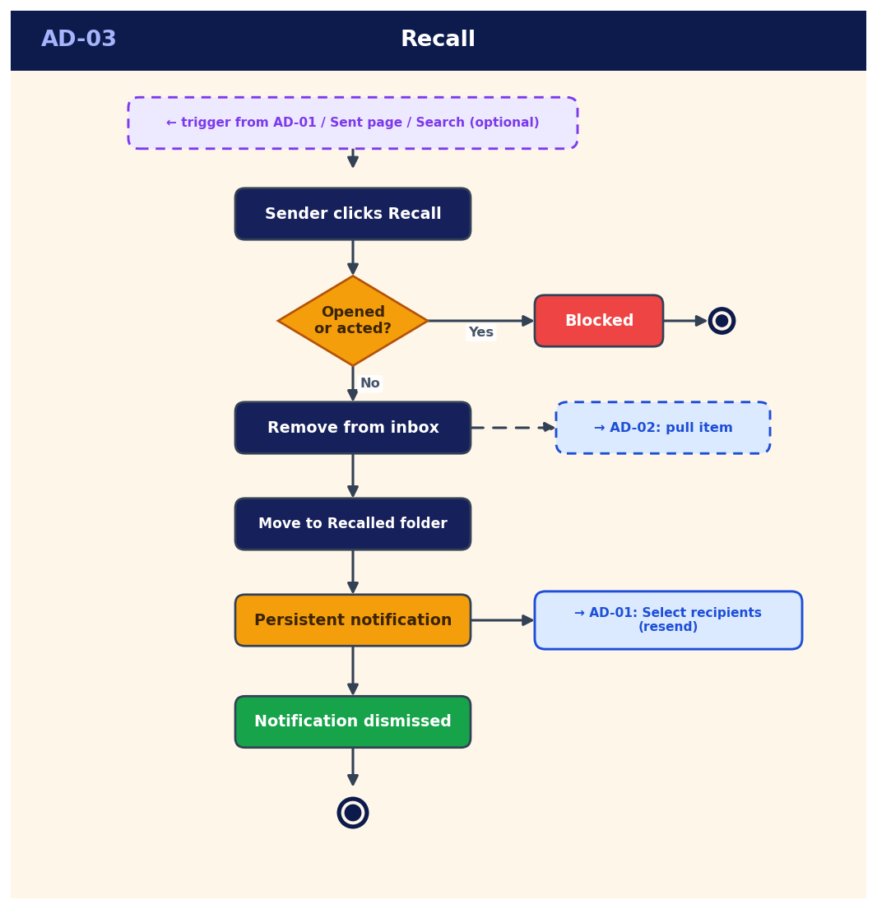

AD-04 — Deadline, Reminders & Escalation
Deadline can be set from AD-01, the Sent page, or the Search page. Reminders fire at 50% and 75%. Each escalation level has an 'Action taken?' decision — if resolved, flow ends. If no action after Deputy Governor, no further escalation.
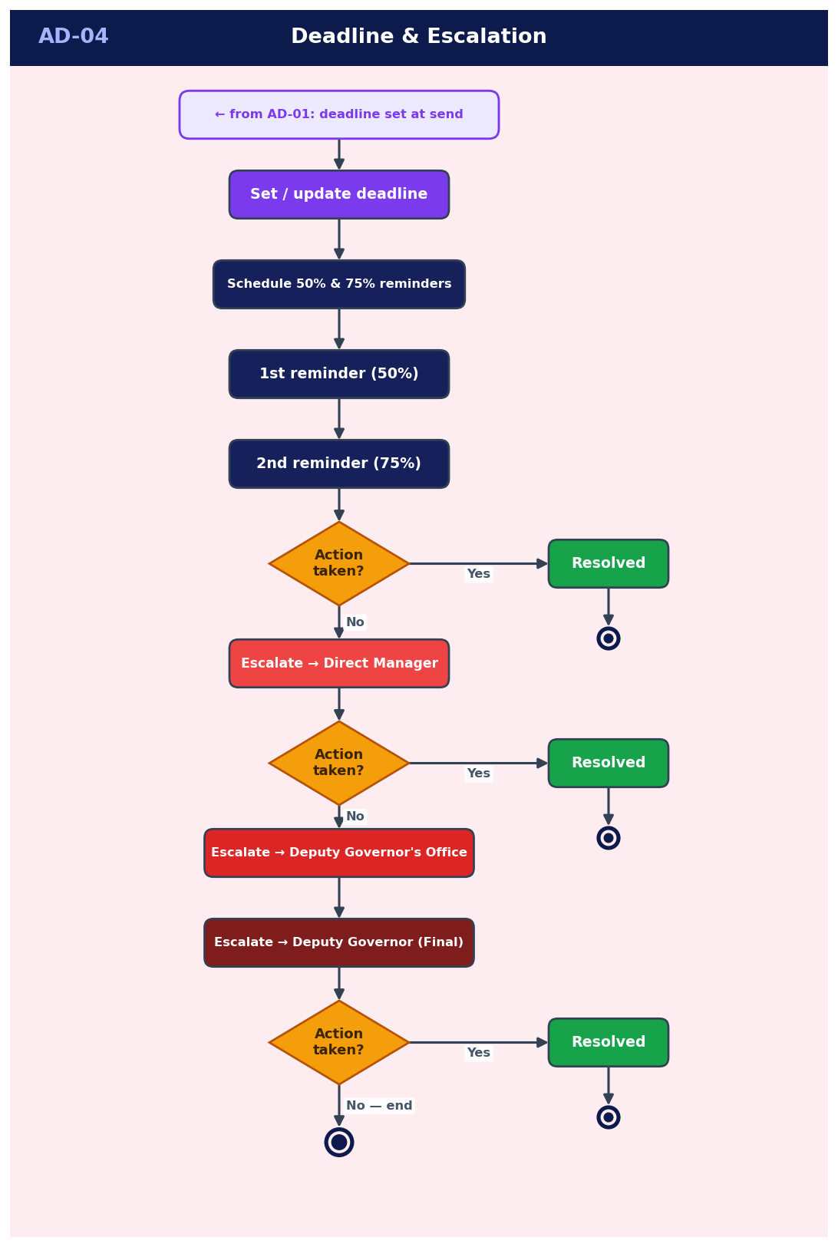

AD-05 — Mention
Handler tags a user or department. Read-only access granted. Mentioned user can view but cannot act. Can be triggered at any stage.
